Wet Mount Documentation

Two new SmartText for wet prep have been implemented in Epic, enabling efficient documentation of findings and seamless billing within a single instance. These templates incorporate SmartData elements that automatically generate charges in Charge Capture based on your selections.
- LEAP WHA WET PREP BASIC
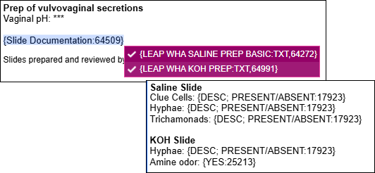
- LEAP WHA WET PREP DETAILED
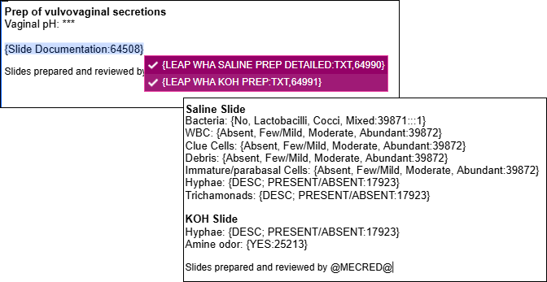
- From your Note, type LEAP WHA WET PREP in the SmartText field.
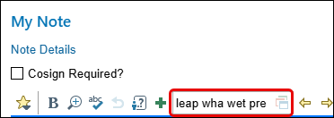
- Select the option that best aligns with your documentation needs, whether you are seeking basic findings (such as clue cells or Trichomonas) or a more comprehensive, detailed insight (including bacteria, debris, or immature/parabasal cells).
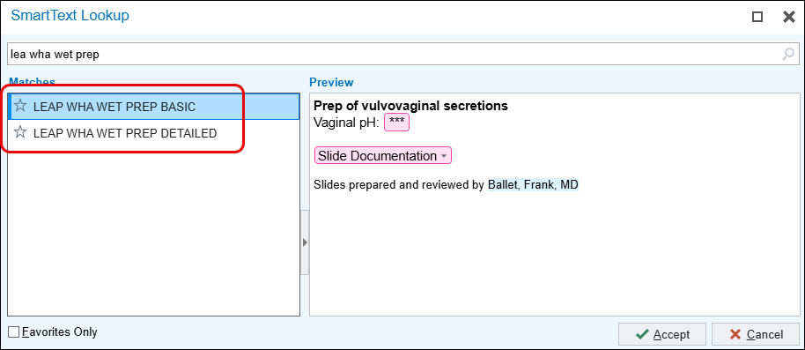
- Document your findings.
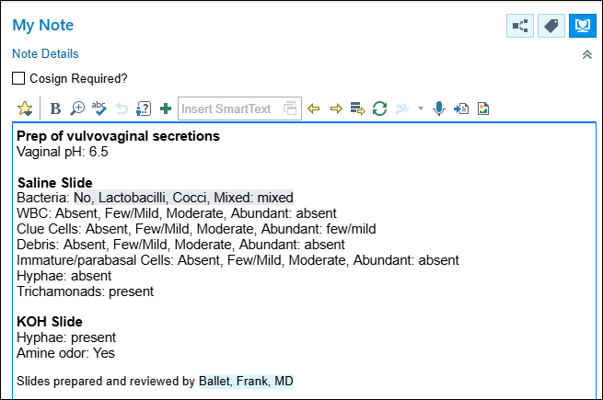
- Go to Charge Capture to see your charges.
- If you only selected and documented Saline, notice the charge that dropped.
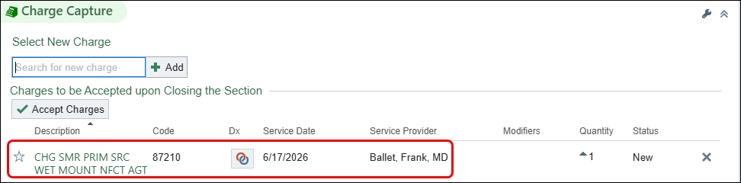
- If you selected and documented Saline and KOH, you will see charges dropped for both.
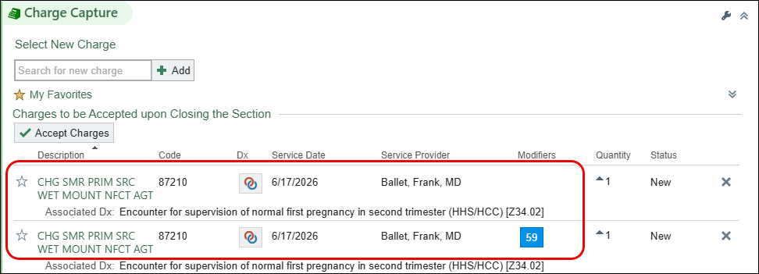

Make your work easier—create a Speed Button so you can quickly add this documentation to your progress note with just one click!
- From your note, click the located in the upper right corner to access the Wrench.
- Click My Notes Settings.
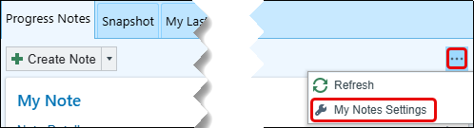
- Under the Speed Button section, click Create New.
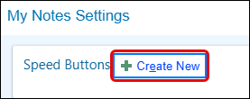
- In the SmartText field, type; WHA WET PREP BASIC, then press Enter.
- Click Accept.
- Caption: rename your speed button to something simple (ie: Basic Wet Prep).
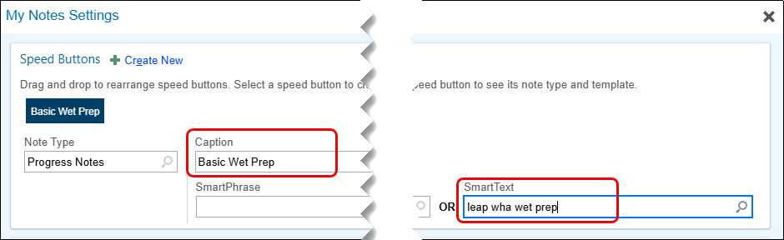
- Repeat these steps if you’d like to add the LEAP WHA WET PREP DETAILED option as well.

